Business Case: Smart Healthcare Appointment & Prescription Management System

Business Case Conceptual Structure | Definitions
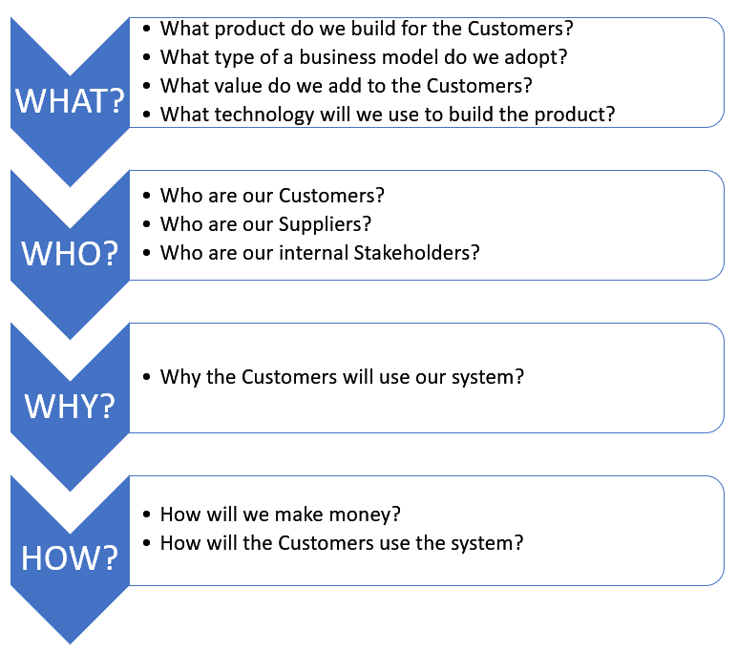 | Customer:  An individual or entity utilizing healthcare services, including patients and healthcare providers.  Supplier:  Entities supplying medical services, including clinics, hospitals, and pharmacies.  Stakeholder:  Individuals or groups with a vested interest in the system, such as doctors, patients, administrators, and developers.  Business Model:  A revenue model combines subscription-based services for healthcare providers and freemium patient access.  Distribution Channel:  Direct distribution via a web-based platform, accessible through desktop and mobile devices.

Team No: 3
Application Name: Smart Healthcare Appointment & Prescription Management System
Category | BC Section | Questions | Answers
WHAT? | Product Overview | Give a brief description of the proposed software product. | The Smart Healthcare Appointment & Prescription Management System is a digital platform that enables patients to book doctor appointments, receive digital prescriptions, and manage their medical records. The system streamlines healthcare services by improving communication between doctors and patients, facilitating efficient appointment scheduling, and enabling prescription tracking.
 | Value Propositions | What Customer business needs are we satisfying? | 1. Reducing Wait Times for Doctor Appointments  The Smart Healthcare Appointment & Prescription Management System allows patients to book appointments in real-time based on doctor’s availability. This reduces scheduling conflicts, minimizes patient wait times, and ensures doctors can optimize their time effectively.  2. Enabling Easy Access to Medical Records and Prescriptions  With this system, all medical records, prescriptions, and appointment histories are stored digitally and can be accessed at any time. This not only improves patient experience but also enables doctors to review previous medical conditions and provide better treatment recommendations.  3. Improving Communication Between Patients and Healthcare Providers  This system bridges the communication gap by providing automated reminders, digital prescription notifications, and direct messaging features. As a result, patient adherence to treatment plans improves, and doctors can deliver better, more personalized care.  4. Automation and Efficiency in Healthcare Facility Administration  This system streamlines routine tasks by automating record management and appointment workflows, reducing administrative burden, minimizing errors, and improving operational efficiency. As a result, healthcare facilities can optimize resource allocation, enhance service delivery, and improve patient satisfaction.
 |  | What value do we add to the Customers? | 1. Value for Patients  (i) Convenient Appointment Scheduling  Patients can easily book appointments through an intuitive online system, ensuring faster access to healthcare services without long wait times or manual coordination.  (ii) 24/7 Secure Access to Medical Records & Prescriptions  A centralized digital platform allows patients to securely view their medical history, prescriptions, and past consultations anytime, eliminating the hassle of managing paper-based records.  (iii) Automated Reminders for Appointments & Medication  The system sends timely notifications for upcoming appointments and medication refills, reducing missed visits and ensuring better adherence to treatment plans.  2. Value for Doctors  (i) Optimized Schedule Management  Doctors can efficiently manage their availability, update their schedules in real-time, and avoid appointment conflicts, ensuring a smoother workflow.  (ii) Instant Access to Patient Histories  A comprehensive patient record system allows doctors to review past medical history, prescriptions, and test results instantly, leading to more informed and accurate treatment decisions.  (iii) Digital Prescription Management  Doctors can issue, update, and manage prescriptions digitally, reducing paperwork and improving prescription accuracy while ensuring compliance with healthcare regulations.  3. Value for Healthcare Facilities  (i) Automation of Administrative Tasks  The system digitizes appointment scheduling, medical record management, and prescription processing, reducing the burden on administrative staff and improving overall efficiency.  (ii) Reduced Operational Costs & Human Errors  By eliminating manual processes, the system minimizes administrative costs, reduces the risk of human errors in scheduling and record-keeping, and enhances the accuracy of patient data management.  (iii) Compliance with Medical Data Security Standards  The platform ensures that all patient records and prescriptions are securely stored and handled in compliance with healthcare data protection regulations, safeguarding sensitive information and maintaining legal adherence.
 | Type of Business Model | What type of business model do we adopt? | 1. Subscription-Based Model for Healthcare Providers  Clinics, hospitals, and independent doctors pay a monthly or annual fee for access to appointment scheduling, patient management, and digital prescription tools.  2. Subscription & Freemium Model for Patients  Basic services like appointment booking and prescription tracking are free, while premium features such as teleconsultations, advanced health analytics, and priority doctor access are available through a monthly or yearly subscription plan.  3. Advertising Model for Pharmaceutical & Insurance Companies  The platform will generate revenue through advertising placements and sponsorships from both pharmaceutical companies and health insurance providers.  - Pharmaceutical Brands: Sponsored content and targeted ads from pharmaceutical companies will help users discover new medications and treatments.  - Insurance Companies: Health insurance providers can advertise their plans and allow users to find in-network doctors and relevant coverage options.  4. Commission-Based Model for Prescription Fulfilment  Partnered pharmacies and diagnostic labs will pay a small commission for prescriptions processed through the platform.
 | Key Resources | What key resources do our value propositions require? | 1. Secure Cloud-Based Database for Patient Records  The platform is hosted on AWS, providing a secure, scalable, and compliant environment for storing patient records, appointment details, and prescriptions. It ensures data integrity, high availability, and compliance with healthcare regulations such as HIPAA and GDPR, enabling real-time access for authorized users.  2. Authentication System for Secure Login & Data Privacy  The system employs JWT-based authentication, and role-based access control (RBAC) to safeguard patient and provider data. This ensures that only authorized personnel can access or modify sensitive medical records, enhancing security, privacy, and regulatory compliance.  3. User-Friendly Interface for Patients, Doctors, and Admins  The platform features an intuitive and responsive UI/UX, accessible via a web-based application. This allows patients to book appointments, doctors to manage schedules, and administrators to oversee operations, ensuring seamless navigation and efficiency across all user groups.  4. API Integrations for Pharmacy Connections  The system integrates with pharmacies and diagnostic labs for prescription fulfillment and test result access. These integrations create a connected healthcare ecosystem, improving patient experience and streamlining provider operations.
 |  | What are our Distribution Channels? | 1. Direct Access via Web Application  Users can access the platform through a secure, cloud-hosted web application available on any browser. No installation is required, ensuring easy access for patients, doctors, and administrators.  2. Mobile-Friendly Interface  The system is optimized for mobile use, allowing patients and doctors to book appointments, manage records, and access prescriptions on smartphones and tablets. Future plan includes a dedicated mobile app for iOS and Android for enhanced user experience.  3. Partnerships with Healthcare Providers & Clinics  Collaboration with hospitals, clinics, and independent healthcare providers to integrate our system into their existing operations. Partnering with pharmacies and diagnostic labs for seamless prescription and test result management.
 | Technology | What technology will we use to build the product? | Front-End: React.js – Ensures a fast, responsive, and user-friendly interface.  Back-End: Express.js – Provides a lightweight and scalable server-side framework.  Database: PostgreSQL – Secure and reliable relational database for structured data storage.  Authentication: JWT (JSON Web Token) – Ensures encrypted and token-based user authentication.
 |  | Is it a mobile or desktop application? | Our system is a web-based application designed for seamless access across devices. It is optimized for mobile compatibility, allowing patients, doctors, and administrators to use it on both desktop and mobile browsers.
 | Known Prototypes | What are the known prototypes of your product?  Reference some known portals on the Internet that are similar to your product. You will use these prototypes for developing business and user requirements. | List of Prototypes:  Reference platforms: Zocdoc, Practo, MyChart.
WHO? | External Customers | Who are our customers? | 1. Patients—Individuals who use the platform to search for doctors, book and manage appointments, receive digital prescriptions, and access their medical records conveniently from anywhere.  2. Doctors—Healthcare professionals who utilize the system to manage their schedules, review patient histories, issue digital prescriptions, and update medical records, ensuring efficient and informed patient care.  3. Healthcare Providers (Clinics & Hospitals)—Medical institutions that leverage the platform to oversee doctor availability, manage patient records, ensure regulatory compliance, and integrate with pharmacies and diagnostic labs for seamless healthcare services.
 | External Suppliers | Who are our suppliers?  Does the system exchange data with external systems? For example, banks, delivery contractors, restaurants, etc. | 1. Healthcare Service Providers—Hospitals, clinics, and independent doctors supplying medical services, appointment availability, and prescription management.  2. Pharmaceutical Companies & Online Pharmacies—Partners for digital prescription fulfillment, enabling patients to order medications directly through the platform.  3. Secure Payment Gateways—Financial service providers handle subscription payments and transactions securely, ensuring compliance with industry standards.  - The system may exchange data with insurance providers, diagnostic labs, and telehealth platforms, further enhancing the healthcare ecosystem. These integrations ensure efficiency, security, and scalability, supporting a seamless user experience.
 | Internal Stakeholders | Who are our internal stakeholders?  Do we need a product development group?  Do we need a sales group?  Do we need a finance group (accounts payable, receivable)?  Do we need a customer support team?  Do we need an advertising management group? | - Internal stakeholders include teams responsible for the development, operations, marketing, and financial management of the system. These teams ensure smooth functioning, customer acquisition, and long-term sustainability.  - Yes, a product development team is essential to design, develop, test, and maintain the platform. This includes software engineers, UI/UX designers, and cybersecurity experts to ensure performance, usability, and security.  - Yes, a sales and business development team are needed to onboard healthcare providers, pharmacies, and other partners. Their role includes negotiating contracts and expanding platform adoption in the healthcare industry.  - Yes, a finance team is required to manage subscription payments, process transactions, handle billing, and ensure compliance with financial regulations. They oversee revenue tracking and operational costs.  - Yes, a customer support team is necessary to assist patients, doctors, and healthcare providers with onboarding, troubleshooting, and resolving queries, ensuring a smooth user experience.  - Yes, a marketing and advertising team is essential to promote the platform, drive user engagement, and manage healthcare-related advertising campaigns. They help in branding and customer outreach strategies.
WHY? | Expected Benefits to the Customer | Why do we believe our new product will be better than those already existing on the market? | 1. Improved Appointment Scheduling—Provides real-time availability and automated scheduling, reducing patient wait times and optimizing doctor efficiency.  2. Centralized Medical Records & Prescriptions—Offers a secure, cloud-based repository for easy access to medical histories and prescriptions, eliminating paper-based inefficiencies.  3. Enhanced Security & Compliance—Ensures HIPAA and GDPR compliance with multi-factor authentication (MFA) and role-based access control (RBAC) to protect sensitive patient data.  4. Integrated Pharmacy Services—Supports digital prescriptions, and pharmacy integrations, creating a seamless healthcare ecosystem.  5. User-Friendly, Mobile-Optimized Interface—Designed with an intuitive UI/UX, allowing patients, doctors, and administrators to access the platform easily on both web and mobile devices.
 |  | Why would customers choose to utilize our system? | 1. Seamless & User-Friendly Interface— A well-designed, intuitive platform ensures easy navigation, allowing patients to book appointments, access medical records, and receive prescriptions effortlessly.  2. Paperless Healthcare Management—Digital storage of medical records and prescriptions eliminates the need for physical paperwork, reducing administrative burdens for both patients and healthcare providers.  3. Increased Accessibility for Remote & Busy Patients—Patients can schedule appointments, consult doctors, and access prescriptions from anywhere, making healthcare more accessible for those with busy schedules or in remote locations.
HOW? | System Use | How will external customers interact with the system?  What is the typical system usage scenario for external customers? | External customers, including patients, doctors, and healthcare providers, will interact with the system through a secure web-based platform with mobile compatibility.  1. Patients—Patients will register, search for doctors by specialty and availability, book or reschedule appointments, receive digital prescriptions, and access their medical history.  2. Doctors—Doctors will manage their schedules, confirm, or reschedule appointments, review patient records, issue digital prescriptions, and update medical histories.  3. Healthcare providers—Healthcare providers, such as clinics and hospitals, will oversee doctor availability, manage patient records, ensure compliance with healthcare data privacy regulations, and integrate with pharmacies and diagnostic labs for seamless prescription fulfillment and test result access.  A typical system use case follows a seamless, end-to-end healthcare workflow, ensuring efficiency for patients, doctors, and healthcare providers.  - Appointment Booking – The patient logs into the system, searches for a doctor based on specialty and availability, and schedules an appointment.  - Consultation Process – The doctor receives a notification, reviews the patient’s medical history, and conducts the consultation—either in person or via teleconsultation.  - Medical Record & Prescription Management – After the consultation, the doctor updates patient records and issues a digital prescription, ensuring accurate documentation and follow-up care.  - Prescription Fulfillment – The patient accesses the prescription through the system and sends it to a partnered pharmacy for processing and medication delivery.  - Oversight by Healthcare Providers – Clinics and hospitals oversee the entire process, ensuring efficient scheduling and seamless coordination with pharmacies and diagnostic labs.
 |  | What is the main system use scenario for the internal users? | Internal users, primarily administrators, are responsible for managing system operations and ensuring efficiency:  1. Doctor Profile Management—Admins create, update, and verify doctor profiles, ensuring accurate credentials, specialties, and availability.  2. Appointment Oversight—Admins monitor and manage appointment scheduling, cancellations, and conflicts to optimize doctor availability and patient access.  3. Prescription Tracking—Digital prescriptions are tracked and monitored to ensure compliance with healthcare regulations and seamless integration with pharmacies.  4. System Maintenance & Compliance—Admins oversee data security and user access control to protect patient information.
 | Revenue Generation, Revenue Streams | How will we make money?  Such as Subscription fees, renting, leasing, licensing, brokerage fees, advertising sales, etc. | 1. Subscription Fees from Hospitals and Clinics  Healthcare providers, including hospitals and clinics, will pay a monthly or annual subscription fee to access appointment management, digital prescriptions, and patient record systems.  2. Advertising Partnerships with Pharmaceutical Brands & Insurance Companies  - Pharmaceutical Advertising: The platform will generate revenue through targeted advertising and sponsored content from pharmaceutical companies and healthcare service providers.  - Insurance Advertising & Sponsorships: Health insurance companies can place ads promoting their health plans, offering users personalized insurance options. Potential advertisers include UnitedHealthcare, Blue Cross Blue Shield, Cigna, Aetna, and Humana.  3. Commission from Prescription Fulfillment Services  A commission-based model will be implemented for prescription fulfillment, where partnered pharmacies pay a fee for each transaction processed through the platform.  4. Premium Features for Enhanced Patient Services  Patients will have access to basic services for free, while premium features such as teleconsultations and priority booking will be available through paid subscriptions.

